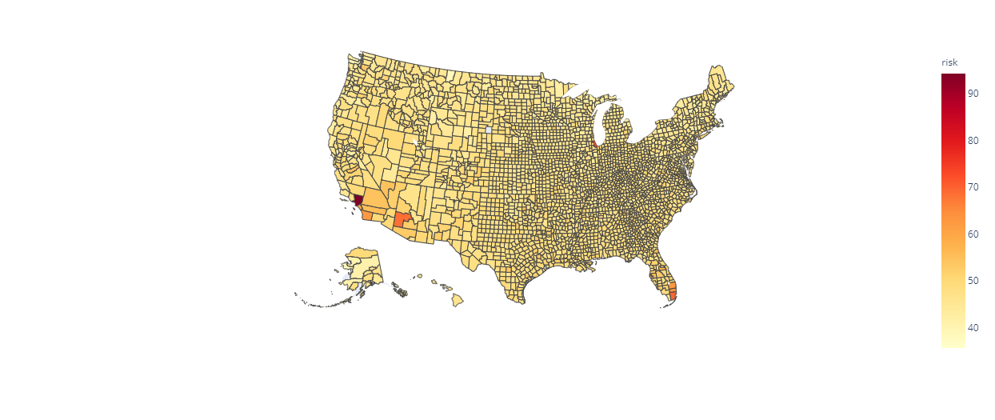

Los Angeles County (dark red) was at most risk (94 percent) followed by some other counties on west coast and in south Florida (orange and dark yellow)

The risk map of January, one of the initial months of vaccination campaign. Most of the counties were at moderate risk with risk score between 40 to 60

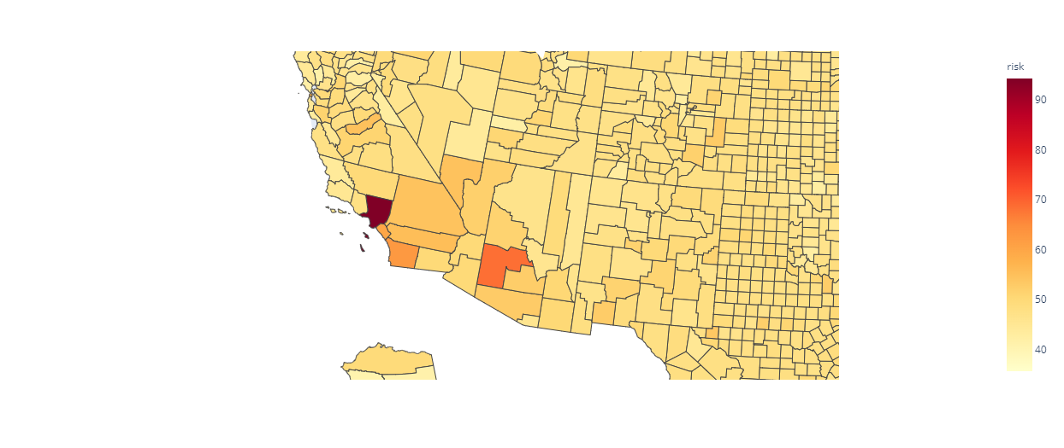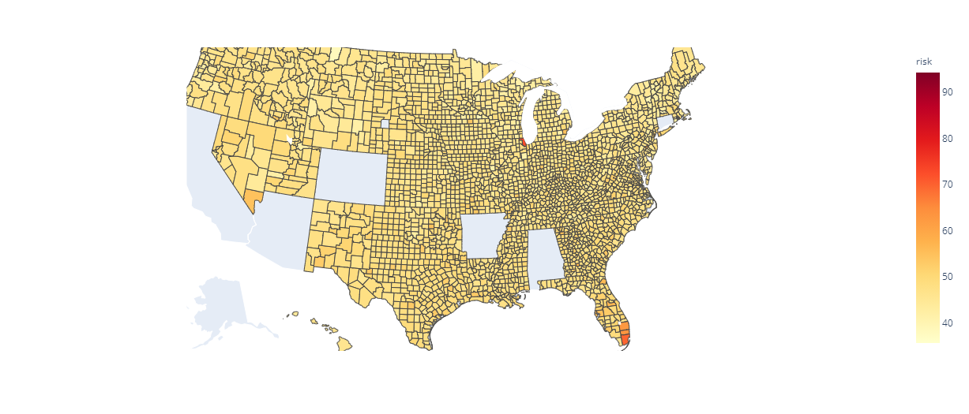

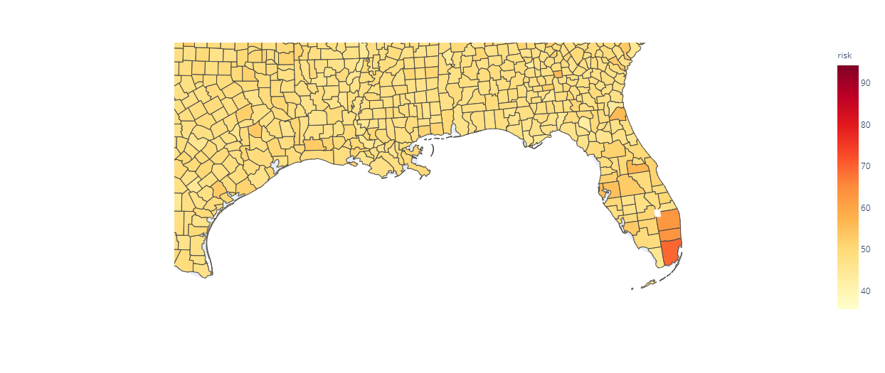



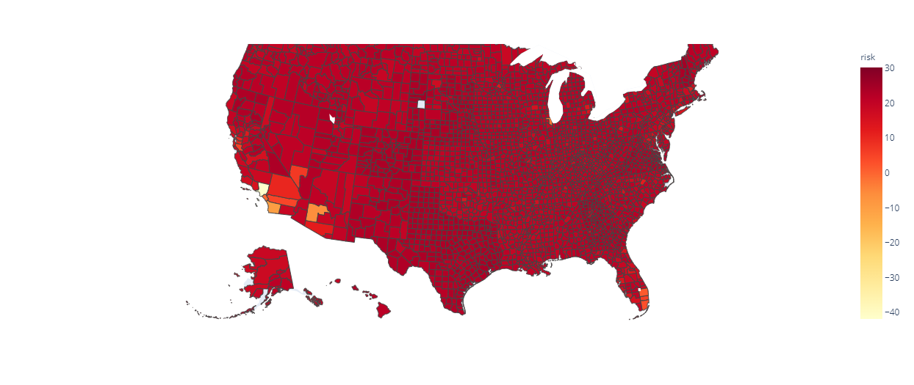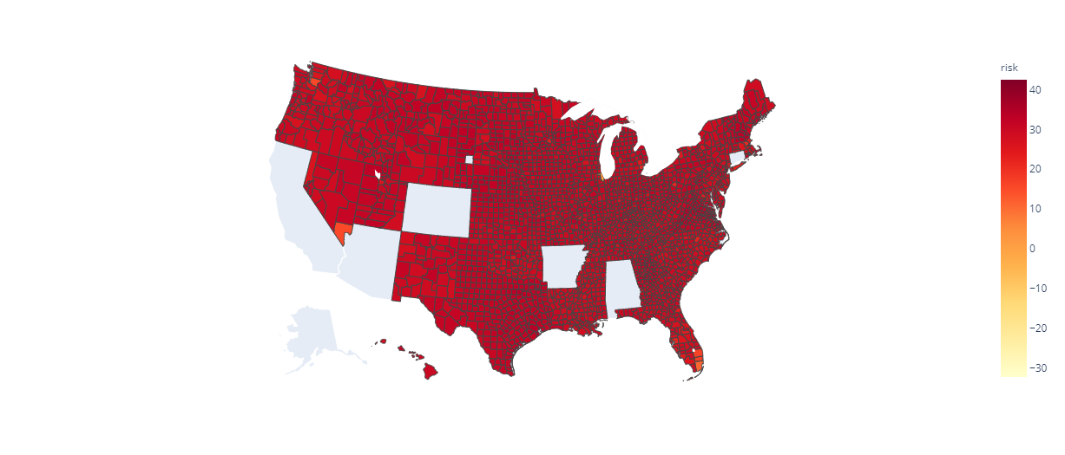

The risk map of subsequent month of February, the period till which vaccination campaign was catching speed thereby reducing risk which was now 20 to 40 in most counties

Recovery was faster in some counties of California and Arizona (orange and light red) which might be attributed to fast rates of vaccination

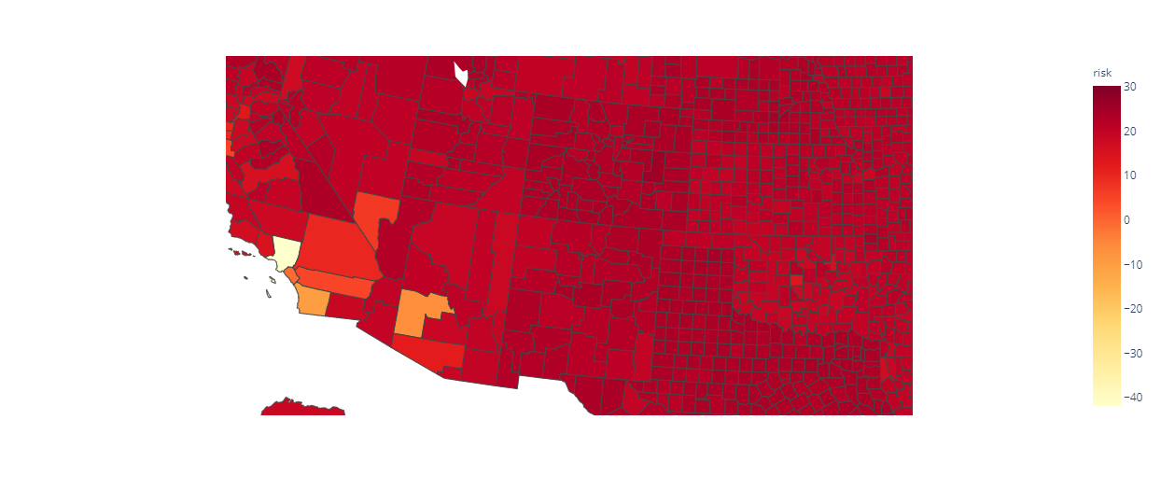

©Sparsh Rastogi 2021. All rights reserved.

A closer view of risk map for counties of east coast and mid west in August

By August, normalcy was achieved in most counties resulting in negative risk score, the most possible reason behind this might be the successful vaccination campaign in most counties

